Group Curriculum
Week | Didactic
1 | Orientation
2 | Goal-Setting and Planning
3 | Reinforcement, Pleasure, and Mastery
4 | Values and Priorities
5 | Finding and Strengthening Social Relationships
6 | Finding Purpose: Increasing Vocational and Educational Activities
7 | Addressing Barriers to Building Structure Part I
8 | Addressing Barriers to Building Structure Part II

BUILDING A LIFE WORTH LIVING WITH STRUCTURE
Portland DBT Institute

BUILDING A LIFE WORTH LIVING WITH STRUCTURE
UNIT 1: ORIENTATION

Overview

- Goals of Building Structure

- Defining Recovery from Mental Health Problems

- Treating Mental Health from the Inside-Out v. Outside-In

- Self-Assessment and Goal-Setting

Goals of Building Structure

- Actively build a Life Worth Living by participating in structured activities.

- Identify structured activities that support your mental health recovery and align with your longterm goals.

- Learn and practice strategies to help you meet your building structure goals and problem-solve challenges that get in the way.

Strategies for Building Structure

- DBT Skills

- Psychoeducation

- Group Discussion, Problem-Solving

- Worksheets, Exercises

- Lived experience, Media

BUILDING A LIFE WORTH LIVING WITH STRUCTURE
Worksheet 1: Key Components for Recovery from Mental Health Problems

Defining Recovery from Mental Health Problems

“The process by which people are able to live, work, learn, and participate fully in their communities. For some individuals, recovery is the ability to live a fulfilling and productive life despite a disability. For others, recovery implies the reduction or complete remission of symptoms. Science has shown that having hope plays an integral role in an individual’s recovery.” – President’s New Freedom Commission on Mental Health (2003)

Other scientifically-supported factors in mental health recovery:
- Treating mental health problems; Maintaining overall health and wellbeing
- Strong social relationships and community support
- Sense of purpose through work, education, volunteering, contributing

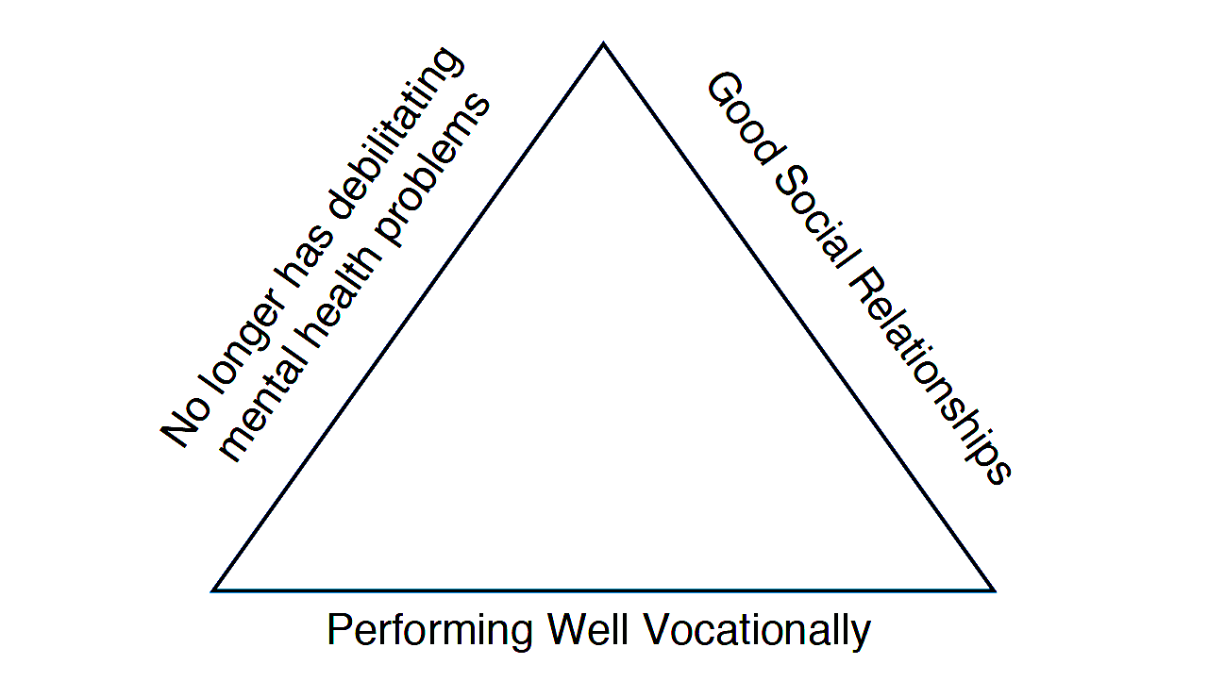

Does this definition resonate with you? What might recovery look like for YOU?
_____________________________________________________________________________________________________________________________________________________________________________________________________________________________________________________________________________________________________________________________________________________________________________________________________________________________________________________________________________________________________________________________________________

List any additional Wise Mind domains that matter for YOU to have a life worth living (e.g., Having a spiritual practice; doing hobbies, creative projects, etc):

- ____________________________________________________________________________
- ____________________________________________________________________________
- ____________________________________________________________________________
- ____________________________________________________________________________
- ____________________________________________________________________________
BUILDING A LIFE WORTH LIVING WITH STRUCTURE
Worksheet 2: Finding a Middle Path Between Inside-Out and Outside-In
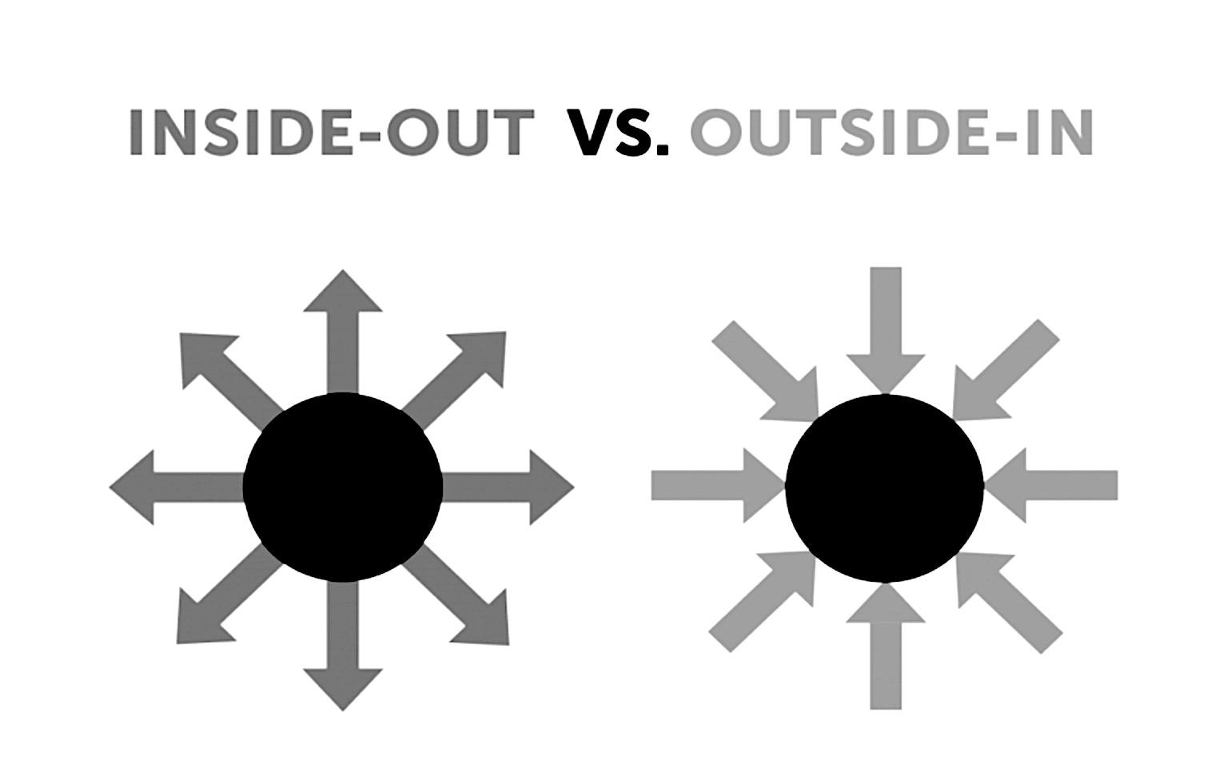

Treating Mental Health Problems from the Inside-Out: Place focus on treating mental health problems. Other areas of life (work, relationships, etc) improve as a result.

Example: Attending a skills training group. Result: Learn skills to regulate emotion, tolerate distress, increase interpersonal effectiveness, and live mindfully. With practice, your skills help you achieve your goal of returning to school.

Treating Mental Health Problems from the Outside-In: Engage in activities (not necessarily treatment-related) that naturally improve mental health.

Example: Volunteering in the community. Result: Distract effectively, build meaningful relationships, develop a sense of fulfillment, contribute by helping others, and improve mental health.

Where is your focus currently? Which end of the dialectic do you tend towards? ___________________________________________________________________________________________________________________________________________________________________________________________________________________________________________________________________________________________________________________________

What does a Wise Mind middle path look like for you?
___________________________________________________________________________________________________________________________________________________________________________________________________________________________________________________________________________________________________________________________
_________________________________________________________________________________________________________
_________________________________________________________________________________________________________

BUILDING A LIFE WORTH LIVING WITH STRUCTURE
Worksheet 3: Self-Assessment and Goal Setting

Step 1. Write out your typical current weekly structure using the three domains—mental health, social, and vocational/educational—and any others you identified as important for building a life worth living (e.g., spiritual, creative).

Step 2. Using the graphic below, tally up hours spent in each domain and record your observations. Ask yourself: What’s missing?

Step 3. Set Wise Mind goals. How many hours per week would you, ideally, like to spend Building Structure in each domain?

Time | Monday | Tuesday | Wednesday | Thursday |  | Friday |  | Saturday |  | Sunday
Morning

MIDDAY

Evening

Hours by Domains
 |  |  |  |  | Current |  |  |  | Goal*
Therapy-Related Efforts
Building, Sustaining Relationships
Attending Work, School
*Identify a timeframe for reaching your goal. Consider a month.

BUILDING A LIFE WORTH LIVING WITH STRUCTURE
UNIT 2: GOAL SETTING AND PLANNING

Goal Setting and Planning for a Life Worth Living

- Goal setting is the practice of creating an action plan to guide and motivate you to do or accomplish a task.

- Effective goal setting is scientifically shown to help us achieve our goals. This research comes from Locke and Latham’s (1990) Goal-Setting Theory.

- Goal setting is a skill that we develop with practice.

Building a Life Worth Living is a longterm goal that can be broken into specific short-term or ongoing goals.

Goal-Setting 101

Certain factors increase the likelihood that you will meet your goal.

- Get clear on what your goal is, be specific. One helpful way to remember is the SMART acronym.
- Set a challenging, but reasonable goal. Research shows that setting a challenging goal can lead to higher goal performance, so long as the goal is realistic and attainable.
- Come up with a plan to meet your goal. Break your goal into concrete steps.
- Identify DBT skills to help you meet your goal. Practice linking each step to a specific skill.
- Commit to your goal. People are more likely to do something they commit to. Make an inner commitment, share your goals with your therapist or group leader, and/or ask others for accountability.
- Tap into Wise Mind by balancing Being Mind and Doing Mind. Focus on the process of working towards your goals. Be mindful of perfectionism and inflexibility.

BUILDING A LIFE WORTH LIVING WITH STRUCTURE
GOAL SETTING AND PLANNING

SMART Goals
SMART is an acronym to help you set effective, behaviorally specific goals.

Specific: Come up with a specific plan to accomplish your goal.
Measurable: Decide how you will know when the goal is met.
Attainable: Set a realistic goal. Consider your knowledge and skills. Is my goal reasonably challenging? What skills will I use to accomplish my goal?
Relevant: Make sure your goals are relevant to you. What are your longterm objectives? What do you value?
Time-oriented: Set a realistic deadline or end-date for the task.

Walking the Middle Path Between Doing and Being Mind
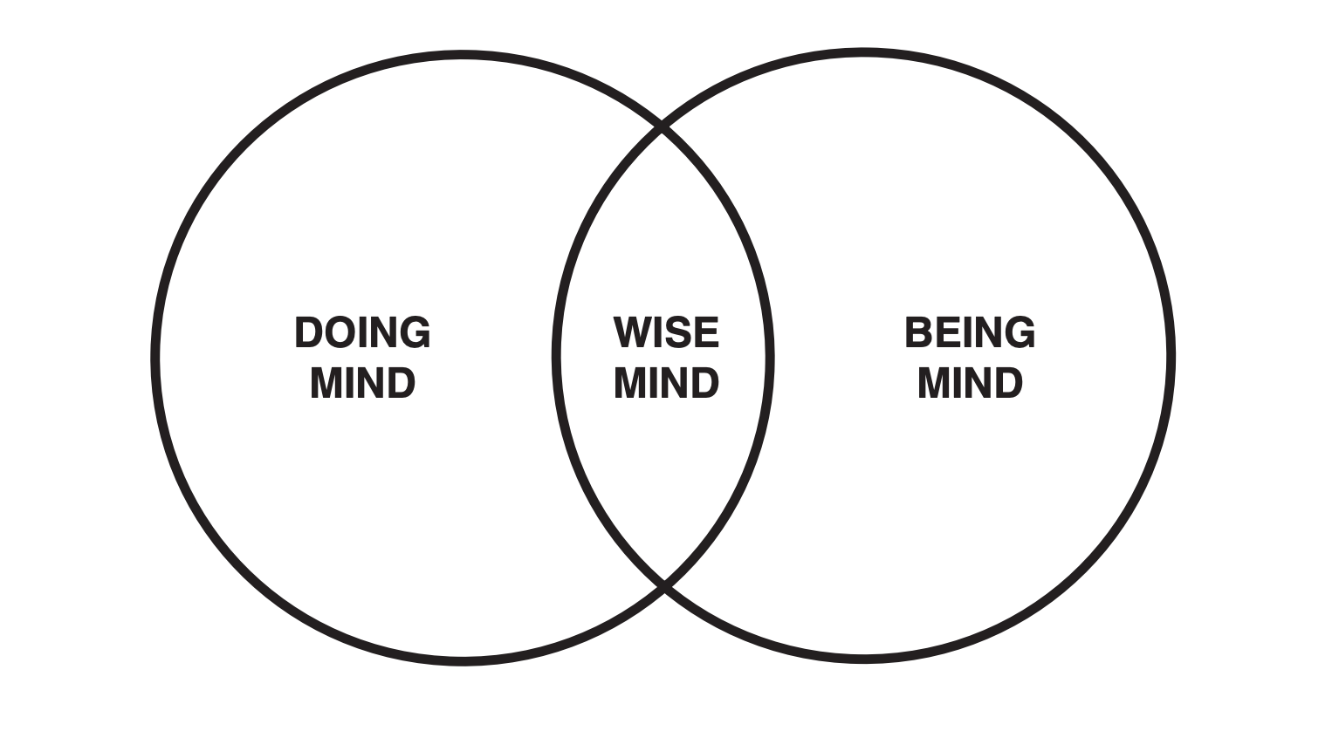
Doing Mind: Ambitious, goal-oriented, discriminating.
Being Mind: Curious, nothing-to-do mind, present-oriented.
Wise Mind: A balance of doing and being; the middle path.
When in Wise Mind you: throw yourself into working towards goals. Let go of perfectionism and having to achieve your goals. Enhance your awareness while engaging in activities.

From DBT Skills Training Handouts and Worksheets, Second Edition by Marsha M. Linehan. Copyright 2015 by Marsha M. Linehan.
BUILDING A LIFE WORTH LIVING WITH STRUCTURE
GOAL SETTING AND PLANNING

When Goals Are Not Met

- Assess: Is my goal still important to me? If not, you may consider setting a different goal. If you are undecided, try a PROS/CONS. Ask Wise Mind: What are the PROS and CONS of working on this goal?

- Identify what is getting in the way (e.g., intense emotions, a barrier in your environment, you don’t have the skill needed to meet your goal, etc).

- Practice flexibility. You may need to adjust your plan. This can be a frustrating, but necessary part of the goal setting process.

- Engage in problem solving and come up with an actionable next step (i.e., practice a skill to help you meet your goal).

When Goals Are Met

- Reward yourself for meeting your goals by figuring out what reinforces you (e.g., Finish your job application, then hang out with a friend).

- Mindfully observe the outcome of meeting your goals. Ask Wise Mind: How does it feel to meet my goal? What do I notice?

- Remember to celebrate your progress!

BUILDING A LIFE WORTH LIVING WITH STRUCTURE
Worksheet 4: Effective Goal Setting

Step 1. Set your goal. What goal do you want to meet? Describe below.
_________________________________________________________________________________________________________

Remember, effective goals are:

Specific
Measurable
Attainable
Relevant
Time-Oriented

Step 2. Set a deadline. I want to meet my goal by (date): ________________________

Step 3. Plan the steps to meet your goal.

Step 1: ________________________________________________________________________________________________

Step 2: ________________________________________________________________________________________________

Step 3: ________________________________________________________________________________________________

Step 4: ________________________________________________________________________________________________

Step 5: ________________________________________________________________________________________________

Step 6 (add additional if needed): _________________________________________________________________

Step 4. How will you keep track of your goal? (E.g., Weekly planner, reminder, sticky note, alarm, app, etc).
________________________________________________________________________________________________________

Step 5. What skills will you use to meet your goal? Brainstorm skills that link to your goals. Keep the list handy as a reminder to use your skills (e.g., One-mindfulness, effectiveness, wise mind, problem-solving, cope-ahead, etc).
____________________________________________________________________________________________________________________________________________________________________________________________________________________________________________________________________________________________________________________________________________________________________________________________________________________________________
__________________________________________________________________________________________________________________________________________________________________________________________________________________

BUILDING A LIFE WORTH LIVING WITH STRUCTURE
Worksheet 5: Building Weekly Structure

One of the most effective ways to improve your mood and create a life worth living is to build structure (planned activities) into your weekly routine. Mapping out the upcoming week can help you stay on track with your goals and structure up your time. It can also help you find a Wise Mind balance between being mind and doing mind by providing a visual representation of your schedule. For example, if you notice your upcoming week looks very busy, you might consult Wise Mind: What do I need to stay on task this week? Do I have time to rest? How will I find balance?

Time | Monday | Tuesday | Wednesday | Thursday | Friday | Saturday | Sunday
AM

MIDDAY

EARLY PM

EVENING

Notes: ___________________________________________________________________________________________________________________________________________________________________________________________________________________________________________________________________________________________________________________________
BUILDING A LIFE WORTH LIVING WITH STRUCTURE
UNIT 3: REINFORCEMENT, PLEASURE, AND MASTERY

Behaviorism

- Behaviorism is an approach to understanding how human behavior is learned and maintained over time.

- The principles of behaviorism can be used to increase behaviors we want to engage in and decrease behaviors we don’t want to engage in.

- Behaviorism can help us improve mood and figure out what’s driving our behavioral patterns.

Behavior and Reinforcement

Behavior: A behavior is anything that can be rewarded or reinforced. Examples: Actions, thoughts, emotions, beliefs, etc.

Reinforcers: Reinforcers are consequences that increase behavior (i.e., make a behavior more likely to happen again).

- Positive reinforcement: Positive reinforcement increases behavior by providing a “reward” or positive consequence.
Example: Paychecks provide monetary reinforcement for going to work. Employees continue to work, even on days when they don’t receive a paycheck, because they know a reward is coming.
Behavior = Working
Reinforcer = Money

- Negative reinforcement: Negative reinforcement increases behavior by taking away an unpleasant or negative consequence.
Example: Cleaning your house to get rid of a mess.
Behavior = Cleaning
Reinforcer =Get rid of mess

- Natural reinforcers: A stimulus that is inherently reinforcing and does not require learning. Examples: Sleep, food, water, etc.

Shaping and Behavioral Activation

Shaping: Shaping refers to the process of reinforcing behavior in small steps to achieve a goal by rewarding behaviors that bring one closer to a desired result.

Example: A baby learning to walk.
Caregiver reinforces baby for: Rolling over Crawling Standing Taking first step Walking

Behavioral activation: Behavioral activation is a strategy to improve mental health by increasing behaviors that are positively reinforcing or rewarding in the longterm. This is accomplished through planning and participating in activities that align with your values.

Participating in scheduled activities can provide positive reinforcement in the form of gaining pleasure or a sense of mastery.

Example: Getting a job. At work, you participate in activities that distract you, build new relationships, gain autonomy, earn money, and develop a sense of mastery in the tasks you perform. In the longterm, you notice an improvement in your mood.

Pleasure vs. Mastery

- Pleasure refers to activities that bring you satisfaction and enjoyment. Examples of pleasurable activities might include: Reading, pets, hanging out with friends, having a romantic relationship, listening to music, creative projects, eating foods you love, etc.

- Mastery refers to activities that develop your skills, sense of competence, and improve the way you feel about yourself. Examples: Having a job, learning a new skill, paying your bills, practicing DBT skills, volunteering, education, etc.

- Pleasure and mastery are reinforcers!

Balancing Pleasure and Mastery with Wise Mind

- Identifying and participating in activities that provide pleasure and/or a sense of mastery can help you accumulate positive emotions and experiences.

- It is important to find a Wise Mind balance of pleasure and mastery activities. Be on the lookout for emotion mind masquerading as Wise Mind!

- When you are in emotion mind, it can be tempting to engage in activities that are immediately reinforcing, like watching TV. Before you know it, you’ve spent the entire day watching TV and avoided other tasks on your to-do list. Notice your activity patterns when you are in emotion mind and work to find a Wise Mind balance of pleasurable and mastery activities. In Wise Mind, pleasure and mastery activities may overlap (e.g., taking a course on a topic you enjoy). Note: It can be helpful to schedule activities during times of the day when you are most vulnerable.

Brainstorm: What types of recovery-oriented activities do you find pleasurable?
_________________________________________________________________________
_________________________________________________________________________
_________________________________________________________________________
_________________________________________________________________________
_________________________________________________________________________

What types of recovery-oriented activities give you a sense of mastery?
_________________________________________________________________________
_________________________________________________________________________
_________________________________________________________________________
_________________________________________________________________________
_________________________________________________________________________

BUILDING A LIFE WORTH LIVING WITH STRUCTURE
Worksheet 6: Building Structure with Pleasure and Mastery Activities
Figure out what you’re going to do with your time – particularly during those parts of the day when you are most vulnerable. See if you can also include at least one pleasurable recovery-oriented thing you can do daily or one that helps build your sense of mastery. Write out activities you can do to structure your time and the estimated hours involved in that activity. If it’s pleasurable or likely to give you a sense of mastery, check the box.

Activity | Est.  Hours | P | M | Schedule Now?  Identify date/time/person, etc.
Example: Go to movies with housemate | 3 | X |  | Go with Maria July 12 @ Ark Cinema in PM
1.

2.

3.

4.

5.

Other Notes:

BUILDING A LIFE WORTH LIVING WITH STRUCTURE
UNIT 4: VALUES AND PRIORITIES

Values

- Values are guiding beliefs that shape the way we live our lives.

- Values reflect how you want to behave towards yourself and others.

- Values motivate us to take action.

- Values can change over time.

- Everyone’s values are different.

- In short, values are what matters to YOU.

Why Do Values Matter?

- Values guide behavior and decision-making. They provide a roadmap for how we want to behave and help keep us on track.

- Living by our values can provide a sense of fulfillment and satisfaction.

- Understanding your values can help you prioritize what’s important and focus on areas for building additional structure in your life.

Values vs. Goals

- Whereas goals can be met or achieved with a desired result, values require ongoing action.

- Values are a guiding direction with no destination or end-point in mind.

Linking Values to Goals

- The idea of living fully by your values might seem overwhelming or far off. Remember: Values are the direction we head in, not a destination or end-point. Living by your values is an ongoing process.

- One concrete way to live more fully by your values NOW is to set goals that are meaningful to YOU, and then break those goals into actionable steps.

- Example: A person who values being part of a group might set the goal of increasing social connectedness by joining a club.

- The first step of linking your values to specific goals is identifying what they are.

Create A Plan to Meet Your Goal

- Choose a value to work on NOW. Complete Worksheet 6: Values Self-Assessment to decide an area of focus, then pick one value to prioritize.

- Define what the value means to you. For example, if you value living a life of pleasure and satisfaction, you might define your value as: participating in a variety of pleasurable activities, eating foods you love, having a pet, traveling to new places, etc. Your definition is yours alone. Make sure you are living by YOUR values, and not someone else’s.

- Set a related goal. Refer to the SMART acronym and tips for effective goal setting.

- Outline specific steps you will take to meet your goal, identifying barriers that might get in the way.

- Brainstorm strategies and skills to use if confronted with barriers.

- Avoid avoiding!

Commonly Held Values
Circle values that matter to you.

- Attend to relationships.

- Be part of a group.

- Be creative.

- Be powerful and influential.

- Achieve things in life.

- Live a life of pleasure and satisfaction.

- Keep life full of exciting events, relationships, and things.

- Behave respectfully.

- Advocate for equity and social justice.

- Be self-directed.

- Be a spiritual person.

- Be secure.

- Recognize the universal good of all things.

- Contribute to the larger community.

- Work on self-development.

- Have integrity.

- Others: _________________________________________________________________________
Adapted from DBT Skills Training Handouts and Worksheets, Second Edition by Marsha M. Linehan. Copyright 2015 by Marsha M. Linehan.

BUILDING A LIFE WORTH LIVING WITH STRUCTURE
Worksheet 7: Values Self-Assessment
Step 1. List your values (make sure they are yours, not someone else’s!) in the following domains. Define what each value means to you. Consider what you care about now and what you want to work towards in the future.

Health, Mental Health, Personal Development:
___________________________________________________________________________________________________________________________________________________________________________________________________________________________________________________________________________________________________________________________

Relationships:
___________________________________________________________________________________________________________________________________________________________________________________________________________________________________________________________________________________________________________________________

Vocational, Educational, Sense of Purpose, Skills Development:
___________________________________________________________________________________________________________________________________________________________________________________________________________________________________________________________________________________________________________________________

Other (Leisure, Creativity, etc):
___________________________________________________________________________________________________________________________________________________________________________________________________________________________________________________________________________________________________________________________

Step 2. Consider the values you listed above. Now, on a scale of 1-10, rate the extent to which you are living by your values in each domain. 10 means you are fully living by your values, 1 means your current actions are inconsistent with your values.

Health, Mental Health, Personal Development: _______

Relationships: _______

Vocational, Educational, Sense of Purpose, Skills Development: ________

Other (Leisure, Creativity, etc): ________

What do you observe? Where are you living fully by your values? Do you notice any areas for growth?
___________________________________________________________________________________________________________________________________________________________________________________________________________________________________________________________________________________________________________________________

Pick one value to focus on NOW. Circle it and continue to Worksheet 7: Building Structure with Values.
BUILDING A LIFE WORTH LIVING WITH STRUCTURE
Worksheet 8: Building Structure with Values
Prioritizing your values is one way to create a life worth living and accumulate positive emotions in the longterm. Setting goals that align with your values can help you build structure by focusing on what matters to YOU.

Step 1. Once you’ve chosen a value to focus on, write it down here:
_________________________________________________________________________________________________________

Step 2. Define what the value means to you. What would it look like for you to live more fully by this value?
___________________________________________________________________________________________________________________________________________________________________________________________________________________________________________________________________________________________________________________________

Step 3. Set a goal that aligns with the value you chose:
_________________________________________________________________________________________________________
_________________________________________________________________________________________________________

Step 4. Set a deadline for completing your goal: __________________________________________________

Step 5. Write a list of specific action steps you will take to meet your goal:

- ______________________________________________________________________________________________
- ______________________________________________________________________________________________
- ______________________________________________________________________________________________
- ______________________________________________________________________________________________
- _____________________________________________________________________________________________

Step 6. Looking at the list above, identify barriers that could get in the way of meeting your goal.
__________________________________________________________________________________________________________________________________________________________________________________________________________________

Step 7. Brainstorm strategies and skills you will use if confronted with barriers at each action step.

Step 8. Commit to trying one value-based action this week and record observations here: __________________________________________________________________________________________________________________________________________________________________________________________________________________
_________________________________________________________________________________________________________
_________________________________________________________________________________________________________

BUILDING A LIFE WORTH LIVING WITH STRUCTURE
UNIT 5: FINDING AND STRENGTHENING SOCIAL RELATIONSHIPS

Impact of Social Relationships on Mental Health

- Extensive research shows that social relationships affect mental health.

- Social support is defined as the emotionally sustaining qualities of relationships including emotional and physical comfort from friends, family members, loved ones, and other people in your social network.

- Social support improves mental health by strengthening our ability to cope with stressful events, providing emotional support, reducing emotional distress, promoting healthy behaviors, enhancing self-esteem (Mayo Clinic, 2020), providing a sense of meaning and purpose in life, and enhancing our sense of control (Umberson & Karas Montez, 2010).

- For example, the average stress level of people with social support is lower than people without social support (APA, 2015).

- Social support is also an important factor in mental health recovery. People who identify themselves as being recovered from mental health problems report having strong social relationships.

Impact of Social Relationships on Physical Health and Wellness

- Social relationships also affect overall physical health and wellbeing.

- People with social support tend to live longer and have fewer health problems than people without social support (Umberson & Karas Montez, 2010).

- Scientists believe mental health (in part) accounts for the link between social relationships and physical health.

Quality of Relationships

- Quality determines the overall impact of social relationships on mental and physical health.

- Stressful and destructive relationships have a negative affect on mental and physical health, whereas supportive relationships have a positive affect.

- It is important to identify your needs, objectives, and values in social relationships (i.e., what matters to you in your relationships with other people) so you can think about the types of relationships you want to cultivate in your life.

- In addition to strengthening social relationships, creating a supportive social network may include advocating for yourself, asserting your needs, and ending destructive relationships with the help of your individual therapist.

- What Wise Mind qualities matter to you in relationships (friends, romantic partners, co-workers, family, etc)?
______________________________________________________________________________________________________________________________________________________________________________________________________________________________________________________________________________________________________________________________________________________________________________________________________________________________________________________________________________________________________________________________________________________________________________________________________________________________________________________________________________________________________________________________________________________________________________________________________________________________________________________________________________________________________________________________________________________________________________________________________________________________________________________

Finding New Relationships and Social Groups

- Finding new relationships takes effort and willingness to be strategic!

- With the support of your individual therapist and group leaders, now is the ideal time to practice making new social connections.

- This may involve getting creative (for example, relying more heavily on technology, videoconferencing, etc, during the pandemic), using new skills, and acting opposite to emotion mind urges.

Where do you typically find new relationships (e.g., online, work, groups, classes, etc)? ________________________________________________________________________________________________________________________________________________________________________________________________________________________________________________________________________________________________________________________________________________________________________
________________________________________________________________________________________________________________________________________________________________________________________________________________________________________________________________________________________________________________________________________________________________________

What strategies have you used to find new relationships in the past (e.g., focusing on shared interests, attending a social gathering, joining a club, inviting to hang out after work, etc)?

________________________________________________________________________________________________________________________________________________________________________________________________________________________________________________________________________________________________________________________________________________________________________________________________________________________________________________________________________________________________________________________________________________________________________________________________________________________________________________________________________________________________________________________________________________

Strategies to Consider

- Focus on people who are near you. Consider groups you are already a part of and start there, focusing on people who are close in proximity to you. For example, many people find social relationships at work, school, or in other groups they are already a part of.

- Focus on shared interests and similarities. Look for people who share similar interests, values, identities, attitudes, beliefs, etc. Focusing on similarities will not guarantee friendship, but it can certainly help make a first connection or strengthen an existing relationship. Example: You overhear your co-worker talking about a TV series you love. You point out your shared interest and they invite you to watch the next episode at their house.

- Research groups to join. Research open groups to join. An open group is a group where new members are welcome. One way to find a new group is to start by choosing an activity you want to participate in, then researching groups for that activity. Examples: Joining an intramural sports team, joining a role-playing game group, joining a group for new parents, joining a band or choir, joining a book club in a topic of interest, joining a spiritual community, taking a group class, etc.

- Volunteering, service, or activism. Find an organization or cause to volunteer for. Volunteering can be a helpful way to meet people who share your values while contributing to your community and increasing feelings of belonging to a cause.

- Go online. The Internet is a helpful resource for finding new groups, meeting people who are similar to you, and hosting gatherings remotely. Look for online groups if you are unable to meet in person due to geographic location, pandemic, etc. Be sure to find a Wise Mind balance of remote and in-person connection.

- Consult Wise Mind. What does finding new social relationships in Wise Mind look like for you (versus emotion mind)?

Skills to Improve and Strengthen Relationships

Just as finding new relationships takes effort, so does maintaining and strengthening relationships in the longterm. Consider the qualities that matter to you in a relationship. How do you want to show up in your relationships with other people?

Strategies to strengthen relationships:

- Express liking (selectively). Express genuine liking of the other person, letting them know you care.

- Reach out, even if you haven’t spoken in a while. Maintaining a relationship will require reaching out to the other person and vice versa. Texting, social media, videoconferencing, and calling can be an effective way to reach out and plan a social activity. If you don’t have time to spend, consider a quick text to let the person know you are thinking of them or ask how they are doing. Reaching out to someone you haven’t spoken to in a while can help bring you closer together.

- Participate mindfully; throw yourself into conversations and activities.

- Listen attentively and one-mindfully to them.

- Use communication skills. Use self-disclosure skillfully, be honest and genuine, communicate openly, ask and respond to questions, and don’t interrupt others.

- Practice validation skills: Pay attention, reflect back what you heard the other person say or do, “read minds” by acknowledging what isn’t being said, show understanding based on their past experiences, what you know about them, etc, acknowledge the valid, and show equality (Linehan, 2015).

BUILDING A LIFE WORTH LIVING WITH STRUCTURE
Worksheet 9: Building A Life Worth Living Network

Consider groups you can join and become a part of. It might be a volunteer group, a class you take, a religious or spiritual community, or a sports team, etc. What matters is that the group is one where you feel a sense of connection to, shares your values, and supports your efforts to build a life worth living. Provide a 0 to 5 rating on how good of a fit the group is to what you care about and feel excited by (0=poor fit; 5=perfect fit).

Groups | Goodness of Fit  Rate 0-5 | What’s the Next Step?
Example: Pottery group | 5 | I need to figure out my schedule for classes at the pottery studio and sign up
1.

2.

3.

4.

5.

6.

7.

BUILDING A LIFE WORTH LIVING WITH STRUCTURE
UNIT 6: FINDING PURPOSE BY INCREASING VOCATIONAL AND EDUCATIONAL ACTIVITIES

Mental Health Benefits of Work and Education

- Working is scientifically shown to improve mental health and is a critical step towards recovering from mental health problems (Modini et al., 2016).

- Work provides opportunities to interact socially, build mastery, practice skills you learn in therapy, and stabilize your mood (McLean, 2020).

- Work and education can help you develop a sense of competency, autonomy, and financial independence.

- Working gives you funds to invest in activities you enjoy, take care of yourself, your family, etc.

- At work or school, you may encounter obstacles that help you learn to regulate your emotions and use DBT skills.

- You may develop supportive relationships with co-workers and classmates or experience feelings of belonging to a team.

- Work and education increase structure by giving you activities to focus on during the day, providing a sense of stability and purpose.

- Work and education also provide opportunities to contribute to your community in meaningful ways.

Why Pursue Work and/or Education Now, Versus Waiting Until Later?

- Consider the benefits of finding employment or educational activities while you are still enrolled in treatment. Can you think of any pros of acting now?

- Major benefits of finding employment or education while attending treatment include: support from your DBT individual therapist, opportunities to problem-solve barriers that get in the way of obtaining employment and education, opportunities to practice skills in real-life contexts, then fine-tune your practice with help from experts, accountability to follow through with your plans, help finding resources and programs that support employment or education, and more!

- Treating from the outside-in: Everyone will have a different balance of treating from the outside-in versus inside-out. Doing both at the same time is essential for recovery from mental health problems. Work and education help treat from the outside-in while you are enrolled in IOP.

- Getting a job now is a stepping-stone to your longterm career and life worth living goals, even if the job does not seem directly relevant.

- Building your work and education history can lead to exciting opportunities in the future and allow you to advance in your career.

- If you don’t know what your longterm vocational or educational goals are yet, finding a job or taking a class now can help you build your skillset as you figure out what is important to you.
Figuring Out When to Get Started

- Going back to work or school versus taking a break: In reality, you may never feel fully ready to return to work or school. Think of a situation in the past where you did not feel ready or comfortable, but acted anyway and succeeded. What was the result?

- How do you know when the decision to take a break from work is Wise Mind versus emotion mind or avoidance? What are signs you are acting on Wise Mind?

- Even if you do not intend on returning to work or school immediately, take advantage of the opportunity to practice and prepare now. As you practice tasks such as preparing your resume, writing a cover letter, or applying and interviewing for a job (even if you don't accept the position), you are learning to skillfully navigate situations you will face in the future.

Finding and Getting Vocational Opportunities

- Take advantage of online resources to help you plan your job or education search and enlist your individual therapist to help you cope-ahead then follow through using DBT skills. The U.S. Department of Labor offers many tools to help people find employment (some are included below).

- Do assessments to help figure out your work skills and values. What makes a job meaningful to you? What types of work-related tasks do you want to be doing?

- Try a job matcher tool based on tasks you like and don’t like: https://www.careeronestop.org/Toolkit/Careers/interest-assessment.aspx

- Complete a career values self-assessment: https://www.careeronestop.org/Toolkit/Careers/work-values-matcher.aspx

- Consider the pros/cons of pursuing a certain type of job or educational activity. Consult Wise Mind to make your decision.

- Make a plan for your job or education search. Break your longterm goal into short-term steps. Develop a plan of action. Present your goals in Target Group and ask to problem-solve any barriers that get in the way.

- Search for positions to apply for or classes to enroll in, even if you are JUST practicing the application process. Use a job search tool to find listings in your are: https://www.careeronestop.org/Toolkit/Jobs/find-jobs.aspx

- Prepare your resume or academic curriculum vitae (cv). For the sake of formatting, it can be helpful to find an example resume or CV to look at. Search for an example resume that belongs to someone in your line of work. For more information on formatting your resume, visit: https://www.careeronestop.org/JobSearch/Resumes/ResumeGuide/WritingYourResume/the-basic-elements.aspx

- Draft a letter expressing interest in the position. Many job applications require a letter of interest expressing why you want the job you are applying for. For a very specific guide to writing your cover letter, visit: https://www.careeronestop.org/JobSearch/Resumes/cover-letters-sample.aspx

- Submit a job or academic application and interview if invited. Follow the instructions included on the job application. If an employer contacts you, cope ahead for your interview by practicing responses to questions they might ask. Consider role-playing with your therapist or a friend or family member.

Accepting New Job Offers, Promotions, or Academic Opportunities

- How do you know when to accept a new job offer or academic opportunity? What factors do you take into consideration when making your decision? If you are offered a job, do you typically accept right away or do you wait? Describe your process:
__________________________________________________________________________________________________________________________________________________________________________________________________________________________________________
____________________________________________________________________________________________________________________________________________________________

- How do you know when you are ready to accept a promotion? What factors might you take into consideration?
__________________________________________________________________________________________________________________________________________________________________________________________________________________________________________
____________________________________________________________________________________________________________________________________________________________

Strategies to Consider:

- Wise Mind. Ask Wise Mind. What does accepting an offer in Wise Mind look like for you?

- Pros/Cons. Write out the pros and cons of accepting a new job offer, promotion, or academic opportunity.

- Identify short-term and long-term consequences. Once you have listed the pros and cons, identify any short-term and long-term consequences of accepting the job, promotion, or academic opportunity.

- Effectiveness. Think of your life worth living goals. Will accepting the position, promotion, or opportunity be effective towards meeting those goals?

BUILDING A LIFE WORTH LIVING WITH STRUCTURE
Worksheet 10: Vocational Research and Planning
Complete the job matcher and career values self-assessment on page 29 and fill in the table below. Record any observations at the bottom of this worksheet.

 | Strong Match | Weak Match
Interests: List vocational and/or educational interests that are a strong match for you, followed by interests that are a weaker match.

Tasks: Consider the tasks you might do at work. What types of tasks do you enjoy doing? List tasks that are a strong match, followed by tasks that are a weaker match.

Example: If you are an extroverted person, you might consider tasks that involve other people. If you are an introverted or socially anxious person, you might consider tasks that involve some (but not constant) social contact.

Sense of Purpose: Employment and education can provide a sense of purpose. What do you value in your work or education? What types of work or education activities give you a sense of purpose?

What do you observe? Do you agree, generally, with the results of your career values and job matcher self-assessments? Describe any observations below. ______________________________________________________________________________________________________________________________________________________________________________________________________________________________________________________________________________

BUILDING A LIFE WORTH LIVING WITH STRUCTURE
UNIT 7: ADDRESSING BARRIERS TO BUILDING STRUCTURE, PART I

Barriers to Building Structure

In all likelihood, barriers will arise as you practice building structure and creating a life worth living. Deciding how you will respond to barriers ahead of time is an effective strategy for reducing in-the-moment suffering and distress when you are faced with difficulties along the way. Knowing how you will respond to barriers can also help motivate you to try challenging tasks by giving you a sense of control and preparedness, and by showing you that coping with challenges is possible. That is, they are usually not a complete catastrophe!

Common barriers in the way of building structure:
- Mood, emotions, low motivation
- Environmental factors (e.g., time, money, life gets in the way, etc)
- Lack of skills or knowledge needed to accomplish goal
- You get disorganized, forget, or lose track of your plans
- You set goals that are too difficult or too easy for you
- Others: ________________________________________________________________

What barriers or problem scenarios have you encountered working towards your Building Structure and Target Group goals? Record observations below.
________________________________________________________________________________________________________________________________________________________________________________________________________________________________________________________________________________________________________________________________________________________________________

Think of a time you were met with a challenge that stood in the way of accomplishing a goal, but successfully completed the goal anyway or adapted your goal to make it possible despite the barrier. What did you do to address the problem?
__________________________________________________________________________________________________________________________________________________________________________________________________________________________________________________________________________________________________________________________________________________________________________________________________________________________________________________________________

Toolkit for Addressing Barriers to Building Structure:
Problem Solving, Acceptance, and Opposite Action

- When thinking about how to address a barrier, it can be helpful to consider whether problem-solving (taking action), acceptance (letting go), or changing your emotional response (acting opposite to what your emotions are telling you to do) will be most effective.

- First, consider the facts of the situation. Nonjudgmentally observe and describe the problem scenario.

- Be aware of all-or-nothing thinking, self-judgments, and catastrophizing.

- Ask Wise Mind: What is getting in the way? Can I realistically solve or change the problem? Is the situation within my control?

- Problem-Solving: If the problem is in the environment and within your control, move to problem solving.

- Acceptance: If the problem is in the environment and outside of your control, practice acceptance or ‘letting go’ of what you cannot change.

- Opposite Action: If emotions/mood are getting in the way, check the facts and consider doing the opposite of what your emotions are telling you to do.

Problem-Solving

- 1. Describe the situation, sticking to the facts.

- 2. Remember your goal and write it down.

- 3. Brainstorm a list of possible solutions.

- 4. Choose the solution that fits best. Try comparing the pros and cons of multiple solutions if you can’t decide.

- 5. Take action!

Adapted from DBT Skills Training Handouts and Worksheets, Second Edition by Marsha M. Linehan. Copyright 2015 by Marsha M. Linehan.

Acceptance

- When the problem is outside of your control, or you have attempted and reattempted to solve the problem without much success, practice acceptance and let go of what you cannot change.

- Practice saying “yes” to the situation. Notice the signs that you are rejecting reality and turn your mind towards acceptance.

- Practicing acceptance does not mean you are giving up on your goal!

- Example: You apply for your dream job, get called back to interview, but aren’t selected for the position. You were qualified, tried your best, and submitted a strong application. You may never know the reason you weren’t hired, but refusing to accept that you didn’t get the job will only hold you back from trying again someplace else. Practicing acceptance and ‘letting go’ opens the doors to another possibility.

UNIT 8: ADDRESSING BARRIERS TO BUILDING STRUCTURE, PART II

When Mood or Emotions are the Barrier

- When mood or emotions are getting in the way of accomplishing your goal, consider practicing Opposite Action.

- Opposite action can be especially helpful for attempting a goal when the barrier to getting started is lack of motivation from depressed mood or fear of “not feeling ready.”

- In some cases, we may never truly feel ready or fully motivated to accomplish a goal- even if that goal is very important to us in theory!

- Practicing opposite action, particularly when emotion urges for mood-based avoidance behaviors arise (e.g., not trying something, doing something more familiar or comfortable instead, etc), can prompt you to take action NOW and lead to longterm benefits for your mental health. This is an example of treating mental health from the outside-in versus inside-out (waiting for your mood to improve before attempting the new behavioral goal).

Think of a time when you were hesitant to attempt a goal, but tried anyway and succeeded? What was the result?
______________________________________________________________________________________________________________________________________________________________________________________________________________________________________________________________________________________________________________________________________________________________________________________________________

Acting Opposite when Emotions Get in the Way

- 1. Notice when emotions and mood are getting in the way of building structure goals.

- 2. Identify the exact emotion that is getting in the way (e.g., fear, sadness, etc).

- 3. Check the facts. Does your emotion fit the facts of the situation?

- 4. Describe the associated action urge or behavior. What is your emotion telling you to do?

- 5. Ask Wise Mind: Is acting on my emotion effective for meeting my goal?

- 6. If no, practice doing the opposite of what your emotions are telling you to do.

- Example Scenario: Anxiety is getting in the way of socializing with a friend this weekend. Even though spending time with your friend usually improves your mood and your anxiety decreases over time, you notice the urge to cancel last minute and stay home. You identify the emotion as fear/anxiety. Upon checking the facts, you realize that fear does not fit the facts of the situation because in all likelihood, hanging out with your friend does not pose a direct threat to your safety or wellbeing. You identify the action (staying home) as an urge to avoid, consult Wise Mind, and decide that acting on your emotion urge will NOT be effective for meeting your goal. You decide to do the opposite of what your emotions are telling you by instead approaching the situation and meeting up with your friend anyway. Before you leave the house, you practice an ice dive to lower your physiological level of anxiety.

Adapted from DBT Skills Training Handouts and Worksheets, Second Edition by Marsha M. Linehan. Copyright 2015 by Marsha M. Linehan.

Coping with Barriers Ahead of Time

Troubleshooting ahead of time can increase the probability of meeting your goal by giving you a plan for what you will do if met with barriers.

- First, describe barriers that could get in the way of meeting your building structure goal. If there are multiple barriers, focus on the most impactful one first.

- Write a list of skills you would use to cope with the barrier or problem scenario. Be as specific as possible, brainstorming several solutions.

- Imagine the problem scenario in your mind.

- Imagine coping effectively step by step, rehearsing exactly what you would do. Note: It is important that you imagine coping EFFECTIVELY. Worrying about coping ineffectively will not increase your willingness to try a challenging new task!

- Practice relaxation to calm down. Ideas for practicing relaxation include: paced breathing, paired muscle relaxation, self-soothing, etc.

Adapted from DBT Skills Training Handouts and Worksheets, Second Edition by Marsha M. Linehan. Copyright 2015 by Marsha M. Linehan.

BUILDING A LIFE WORTH LIVING WITH STRUCTURE
Worksheet [Insert #]: Addressing Barriers to Building Structure
There are many ways to respond when barriers interfere with meeting your goals. Use this worksheet to help you brainstorm solutions to common barriers.

Common barriers:
- Mood, emotions, low motivation
- Environmental factors (e.g., time, money, life gets in the way, etc)
- Lack of skills or knowledge needed to accomplish goal
- You get disorganized, forget, or lose track of your plans
- You set goals that are too difficult or too easy for you
- Other

Step 1. Identify a building structure activity or goal you wish to complete, but haven’t yet because you are running into barriers. (E.g., Applying for a new job).
__________________________________________________________________________________________________________________________________________________________________________________________________________________
__________________________________________________________________________________________________________________________________________________________________________________________________________________

Step 2. Identify what’s getting in the way of working towards your goal. It will be helpful to choose the barrier that is most impactful, so you can focus on addressing it first. Consider the following options, then describe in further detail below.

- Environment is getting in the way and the problem is within your control.
- Environment is getting in the way and the problem is outside of your control.
- Emotions are getting in the way.
- Other
__________________________________________________________________________________________________________________________________________________________________________________________________________________
__________________________________________________________________________________________________________________________________________________________________________________________________________________

Step 3. Practice a strategy to address the barrier. Consider problem-solving, acceptance, or opposite action, referring to the instructions on pgs. 23-25. Record your observations below:
__________________________________________________________________________________________________________________________________________________________________________________________________________________
__________________________________________________________________________________________________________________________________________________________________________________________________________________
____________________________________________________________________________________________________________________________________________________________________________________________________________________________________________________________________________________________________________________________________________________________________________________________________________________________________

Notes:

